PRESS RELEASE

COMMUNICATIONS AND MEDIA TEAM OF THE 43RD ASEAN SUMMIT 2023

No.127/SP/TKM-ASEAN2023/ENG/9/2023

Cooperation Behind ASEAN Summit Gala Dinner

Jakarta, 11 September 2023 – The 43rd ASEAN Summit was concluded on 7 September. Indonesia, as a host country, is considered to have achieved a double success. Not only in terms of smooth organization of the summit but also the policies and agreements delivered by the conference which are to be implemented in the region and beyond.

The successful implementation of the meetings would not have been possible without a well-organized logistics. One of Indonesia’s largest MICE organizer companies, Pacto Convex, made it possible. As the Professional Conference Organizer (PCO) appointed for the 43rd ASEAN Summit, the business is responsible for various tasks from formulating event concepts and branding; ensuring the readiness of electric vehicles, accommodation, meeting rooms, and plennary rooms; managing decorations, banquets, health facilities, spouse programs, and gala dinner, and, last, but not least, souvenirs.

"Everything was prepared in about a month," said Wiwin Kurniawan from Pacto Convex when contacted by the Communications and Media Team of the 43rd ASEAN Summit on Monday (11 September).

The preparation for this summit included large-scale and massive works. According to Wiwin, they need to maximise all networks and work partners they have. The challenge was harmonysing working frequency and rhythm with all parties to facilitate the process of formulating ideas and implementing them runs smoothly.

Joint Endeavour for Gala Dinner

Rubi Roesli is the architect responsible for the designs used in the 43rd ASEAN Summit. He admitted that he was pleased to be involved in the decoration team. “This is a teamwork. Everyone focuses on the goal of making the event a success. We’re not in favour of anyone’s ego. All inputs are taken and considered. Everything are discussed," he said.

Rubi and team are responsible to design all layouts, starting from the conference rooms at the Jakarta Convention Center of Gelora Bung Karno Complex (GBK), to the bamboo alley leading to the dinner area in the City Forest of GBK, Jakarta. Although it was not his first time designing for a high-level conference, challenges remain.

"When we were in Labuan Bajo (42nd Summit), we took advantage of the extraordinarily beautiful nature. Just by opening the meeting room window, everything is beautiful and comfortable. When the conference was held in Jakarta, the event was held in a building in the city center. The building is nice, recently renovated, and spacious. "So, the challenge is to adapt these rooms according to the scale needed for conferences with different numbers of participants in each room," said Rubi. There are quite a lot of areas within the scope of the task, each of which requires different details.

The overall design idea, all by Rubi and Elwin Mok as a Visual Creative Consultant with supervision from the former Minister of Tourism and Creative Economy Wishnutama, was to incorporate exotic Indonesian natural elements into the room, as a continuation of the design of the previous summit in Labuan Bajo. Therefore, in the welcoming room, a forest with a waterfall was created. "Essentially, we must continue to remind people about nature conservation, according to current issues,“ added Rubi.

To get around the large space, Rubi and his team made a round stage in the middle of the Plenary Hall for the opening and closing of the 43rd ASEAN Summit. “The round stage creates a more fluid atmosphere, an approach that has rarely been used at previous summit-type events. In terms of scale, the room gives more potential to explore. "Meanwhile, the wave pattern on the wall is a visual form which is a continuation of the visuals in Labuan Bajo," he said. Apart from the meeting room, he also designed the delegates room.

Another design that was discussed after the conference was the bamboo alley in the GBK City Forest. "Wishnutama asked to create something to allow comfortable trip from the reception room to the gala dinner."

Finally, the idea was to create a winding hallway, built from rows of bamboo trees of more than five meters high withcertain lighting arrangement to suit the desired effect.

“Those who walk through the tunnel will feel warm. It serves as the intermediary space between the Plataran restaurant and the gala dinner area," said Rubi.

The bamboo hallway acts as a precondition before entering the gala dinner area which was designed and conceptualized by the Kantara team.

Collective efforts made it possible

“Every job comes with lesson. Designing the 43rd ASEAN Summit, I learned about manipulating the scale of space for conference needs," said Rubi.

According to Rubi, the design of a space must also consider how it looks when recorded on video or broadcast on a television screen. Details are the key to harmony.

"I’m lucky to work with colleagues on the same frequency, everything went smoothly, and there were almost no problems," said Rubi, praising Dina Touwani who was responsible for the flowers and plants, and Suparman who made the giant waterfall at the JCC. “The waterfall is my favorite.” concluded Rubi.

Meanwhile, Wiwin agrees about the teamwork. "The success of the summit was a collaborative effort from the thousands of people involved. The important thing is that everyone is aware that the main goal is to make this event a success. Nothing is impossible. "If you work with your heart, there will always be a solution," he concluded. (Budiana/TR/Elvira Inda Sari)

***

For more information, please contact:
Director General of Public Information and Communications of the Ministry of Communications and Informatics – Usman Kansong (0816785320).

Get more information at http://asean2023.id, https://infopublik.id/kategori/asean-2023, and https://indonesia.go.id/kategori/ragam-asean-2023

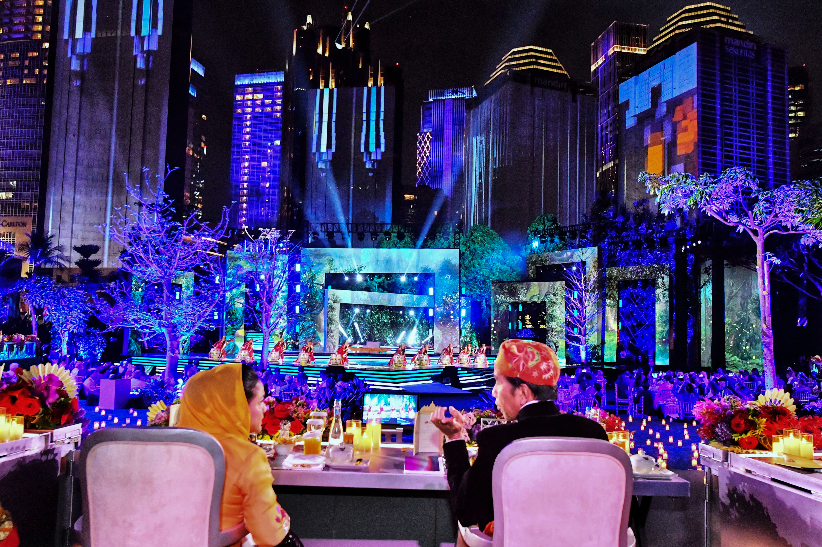
Indonesian President Joko Widodo and First Lady Iriana Joko Widodo enjoy the performance during the Gala Dinner of the 43rd ASEAN Summit at Plataran City Forest, GBK Complex, Senayan, Jakarta, Wednesday (6 September 2023). 2023 ASEAN Summit Media Center/Agus Suparto/pras.

